High Performance Analytics

Divya Jayaprakash

Dxj160830

ER model: Hotels.com(MS Visio screenshot)

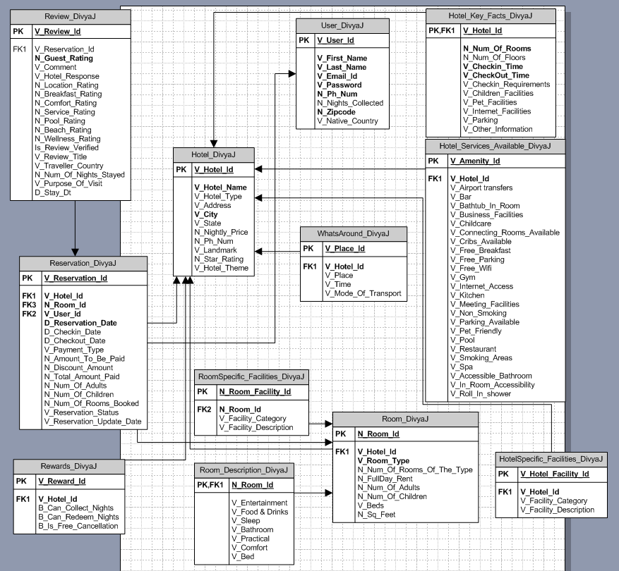

Continued…

Dimensional model: Hotels.com(MS Visio screenshot)

